statstutor community project
encouraging academics to share statistics support resources
All stcp resources are released under a Creative Commons licence

stcp–marshallowen-5b

Emissions Scenario Role Play

Student Role
(See Pages 3&4 for Tutor Role)

You are to play the role of a final year (Year 4) undergraduate student studying BSc Geography and you need help with some statistical analysis relating to your final year project. You have a data set which includes a measure of the level of emissions of a certain chemical (referred to as “P1FCH4”), along with the “Air Temperature” collected at 4 different sites (labelled Site 1, 2, 4 and 5). The data also includes two other continuous variables referred to as “Active Layer” and “Water Table”. Some of the data for Site 1 is listed below.

Site | P1 FCH4 | Air Temperature (ºC) | Active Layer | Water Table
1 | 84.89 | 10.49 | 16.00 | -1.00
1 | 105.79 | 6.38 | 20.67 | 2.50
1 | 85.45 | 7.89 | 22.83 | 2.00
1 | 76.09 | 5.53 | 23.50 | 1.00
1 | 278.40 | 11.84 | 25.67 | 3.00

Your supervisor for your geography project has suggested examining the correlations between the variables and plotting them, to see if there are any relationships between emissions and some or all of the other variables. They have also suggested you use regression to see if emissions can be predicted using some or all of the other variables.

You should tell the statistics tutor all of the above, and that you have used SPSS to obtain the results and plots shown overleaf. You should also tell them that you don’t really know what these results are telling you and that you don’t know how to proceed with the regression using SPSS. The statistics tutor has been given a copy of the data table above but NOT the results and plots shown overleaf so you will need to turn this paper over to show them.

DO NOT OFFER THE FOLLOWING INFORMATION UNLESS YOU ARE ASKED:
You did a statistics module in Year 2 which included simple linear regression but that topic was not developed any further. That module also took place two years ago as you had Year 3 as a placement year. You DON’T have A level mathematics but you DID obtain a grade A at GCSE mathematics, although that was also over 5 years ago now!

You have just 10-15 minutes in which to get some help!

Be ready to report back to the whole group on how the session went.

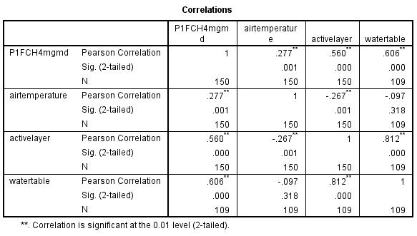

Air temperature and Emissions by Site  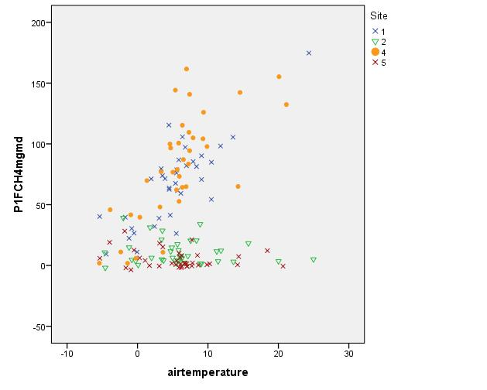 | Active Layer and Emissions by Site  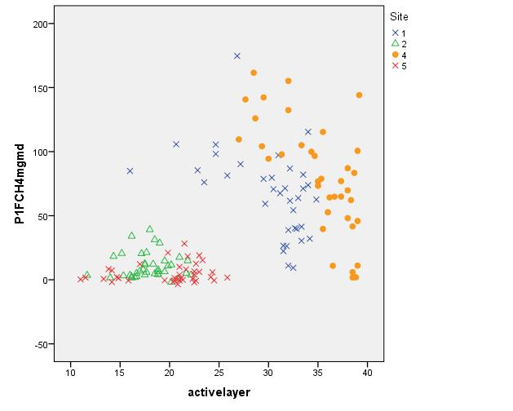

Watertable and Emissions by Site
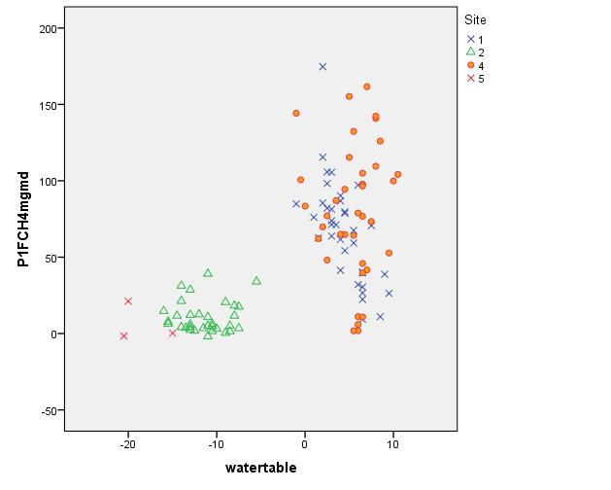

Emissions Scenario Role Play

Tutor Role
(See Pages1&2 for Student Role)

You are to play the role of a statistics tutor.

A final year (Year 4) undergraduate student studying BSc Geography has booked an appointment with you to get some help with some statistical analysis relating to their final year project. They have emailed you some details about their data which includes a measure of the level of emissions of a certain chemical (referred to as “P1FCH4”), along with the “Air Temperature” collected at 4 different sites (labelled Site 1, 2, 4 and 5). The data also includes two other continuous variables referred to as “Active Layer” and “Water Table”. Some of the data for Site 1 is listed below.

Site | P1 FCH4 | Air Temperature (ºC) | Active Layer | Water Table
1 | 84.89 | 10.49 | 16.00 | -1.00
1 | 105.79 | 6.38 | 20.67 | 2.50
1 | 85.45 | 7.89 | 22.83 | 2.00
1 | 76.09 | 5.53 | 23.50 | 1.00
1 | 278.40 | 11.84 | 25.67 | 3.00

Apart from that all the student has said is that their project supervisor has suggested they should use correlation and regression and so they want some help with those techniques.

You have 10-15 minutes in which to help them!

You will need to think about:
- What information you need from the student to help them effectively;

- The level of ability of the student;

- Whether the analysis suggested by the student’s supervisor is appropriate and if so which variables might be considered as potential predictors in the regression model;

- What help would you give? Would you just advise them what to do and expect them to go away and do it? Would you give them some help with how to do the relevant analysis using their entire data set? Would you need to write down any equations? Would you explain the mathematics behind the technique(s)? What about model checking and multicolinearity etc? Is the student’s work going to be assessed?

- What would you do if you don’t know how to help them with this analysis? You might actually not know how to help them if based on your current knowledge you have no experience of correlation and/or regression!

Be ready to report back to the whole group on the challenges you faced.

